Experiment-1A: Date: 10-07-2026
****
Aim: Write a HTML program, to explain the working of lists.
Source Code:
<!doctype html>
<html>
<head>
<title>Document</title>
</head>
<body>
<h1>Roll No: 249XA33161, Name: Y KALPANA</h1>
<h1>----OUTPUT----</h1>
<br />
<h2>1.Ordered List</h2>
<ol>
<li>MPC</li>
<li>BIPC</li>
<li>HEC</li>
<li>CEC</li>
</ol>
<h2>2.Unordered List</h2>
<ul>
<li>BLue</li>
<li>Green</li>
<li>Black</li>
<li>White</li>
</ul>
<h2>Nested List</h2>
<ul>
<li>
Frontend
<ul>
<li>HTML</li>
<li>CSS</li>
<li>Javascript</li>
<li>React</li>
</ul>
</li>
<li>
Backend
<ul>
<li>Nodejs</li>
<li>MySQL</li>
<li>MongoDB</li>
</ul>
</li>
</ul>
<h2>4.Ordered List inside an Unordered List</h2>
<ol>
<li>Languages
<ol>
<li>English</li>
<li>Telugu</li>
<li>Hindi</li>
</ol>
</li>
</ol>
<h2>5.Definition List</h2>
<dl>
<dt>CPU
<dd>Central Processing Unit</dd>
</dt>
<dt>HTTP
<dd>Hyper Text Transfer Protocol</dd>
</dt>
<dt>GPS
<dd>Global positioning System</dd>
</dt>
</dl>
<h1>----End of the Output--</h1>
<h1>Roll No: 249XA33161, Name: Y KALPANA</h1>
</body>
</html>

Snapshot of the Output Webpage:
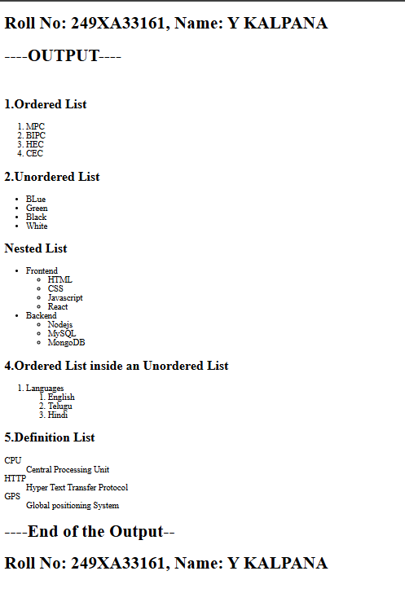


Signature of the Faculty

Experiment-1B: Date: 10-07-2026
****
Aim: Write a HTML program to explain the working of hyperlinks using <a> tag and href, target attributes.
Source Code:
<!doctype html>
<html lang="en">
<head>
<title>Document</title>
</head>
<body>
<h1>Roll No: 249XA33161, Name: Y KALPANA</h1>
<h1>----OUTPUT----</h1>
<h2>Working of Hyperlinks</h2>
<p>To visit Linkedin: <a href="https://in.linkedin.com/">Linkedin</a></p>
<p>To vist Flipcart: <a href="https://www.flipkart.com/">Flipcart</a></p>
<p>
To visit Learnvern: <a href="https://www.learnvern.com/">LearnVern</a>
</p>
<h1>----End of the Output--</h1>
<h1>Roll No: 249XA33161, Name: Y KALPANA</h1>
</body>
</html>

Snapshot of the Output Webpage: 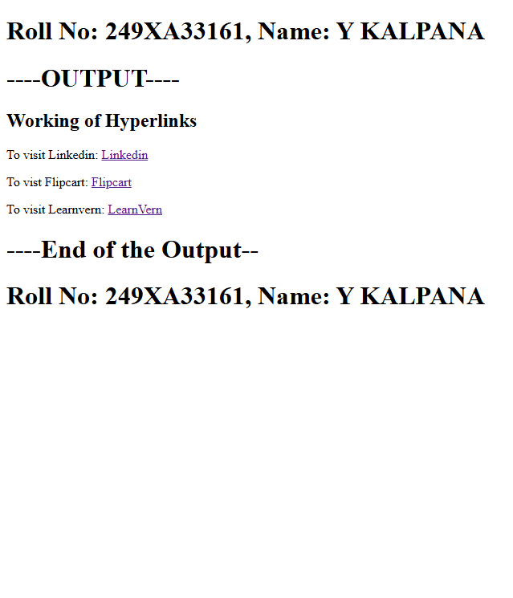

Signature of the Faculty

Experiment-1C: Date: 10-07-2026
****
Aim: Write a HTML program to create a HTML document that has your image and your friend’s image with a specific height and width. Also, when clicked on the images it should navigate to their respective profiles.
Source Code:
<!doctype html>
<html lang="en">
<head>
<meta charset="UTF-8" />
<meta name="viewport" content="width=device-width, initial-scale=1.0" />
<title>Document</title>
</head>
<body>
<h2>Roll No: 249XA33161 , Name: Kalpana</h2>
<h2>---OUTPUT---</h2>
<h1>Clickable Images</h1>
<h2>Linkdin Photo</h2>
<a href="https://in.linkedin.com/" target="_blank">
<img src="images.png" alt="Linkedin photo" width="250" height="250" />
</a>
<br /><br />
<h2>Flipcart Photo</h2>
<a href="https://www.flipkart.com/" target="_blank">
<img src="flipcart.png" alt="Flipcart photo" width="250" height="250" />
</a>
<h2>Roll No: 249XA33161 , Name: Kalpana</h2>
<h2>---END OF THE OUTPUT---</h2>
</body></html>
Snapshot of the Output Webpage: 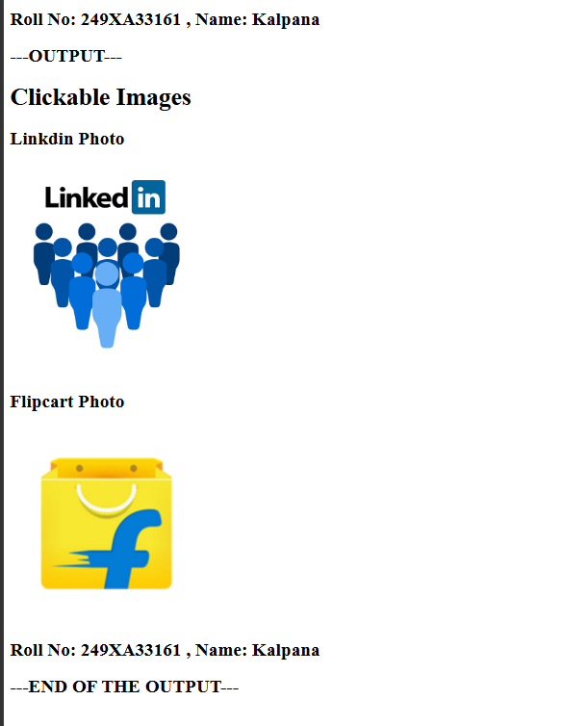

Signature of the Faculty

Experiment-1D: Date: 10-07-2026
****
Aim: Write a HTML program to create a HTML document that has your image and your friend’s image with a specific height
Source Code:
<!doctype html>
<html lang="en">
<head>
<meta charset="UTF-8" />
<meta name="viewport" content="width=device-width, initial-scale=1.0" />
<title>Image Gallery</title>
</head>
<body align="center">
<h2>Roll No: 249XA33161 , Name: Kalpana</h2>
<h2>---OUTPUT---</h2>
<h1>Image Gallery</h1>
<p>Click any thumbnail to view the Full- size Image</p>
<br />
<a href="Instagram.webp" target="_blank">
<img src="Instagram.webp" alt="Linkedin photo" width="150" height="150" />
</a>
<a href="whatsapp.png" target="_blank">
<img src="whatsapp.png" alt="Linkedin photo" width="150" height="150" />
</a>
<a href="youtube.png" target="_blank">
<img src="youtube.png" alt="Linkedin photo" width="150" height="150" />
</a>
<a href="Twitter.jpeg" target="_blank">
<img src="Twitter.jpeg" alt="Flipcart photo" width="150" height="150" />
</a>
<br />
<h2>Roll No: 249XA33161 , Name: Kalpana</h2>
<h2>---END OF THE OUTPUT---</h2>
</body>
</html>
Snapshot of the Output Webpage: 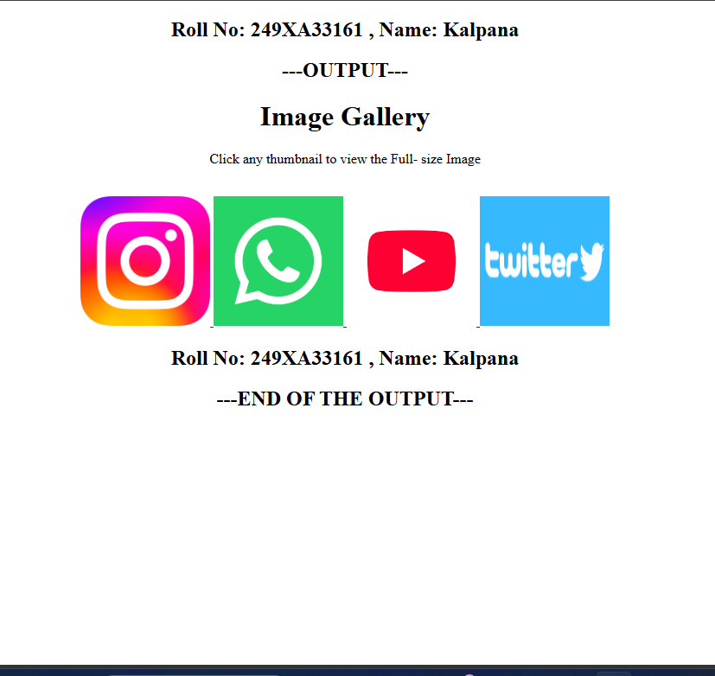

Signature of the Faculty

Experiment-2A: Date:
****
Aim: Write a HTML program to create a HTML document that has your image and your friend’s image with a specific height
Source Code:
<!doctype html>
<html lang="en">
<head>
<meta charset="UTF-8" />
<meta name="viewport" content="width=device-width, initial-scale=1.0" />
<title>HTML Table Example</title>
</head>
<body>
<h2>Roll No: 249XA33161 , Name: Kalpana</h2>
<h2>---OUTPUT---</h2>
<h2>Student Course Result Table</h2>
<table border="2" cellpadding="10" cellspacing="0">
<tr>
<th>S.No</th>
<th>Name</th>
<th>Year</th>
<th>Course Name</th>
<th>Percentage</th>
</tr>
<tr>
<td>1</td>
<td>Kalpana</td>
<td>III</td>
<td>Python</td>
<td>90</td>
</tr>
<tr>
<td>2</td>
<td>Dhana</td>
<td>II</td>
<td>Java</td>
<td>80</td>
</tr>
<tr>
<td rowspan="2">3</td>
<td rowspan="2">Ramya</td>
<td>III</td>
<td>ML</td>
<td>65</td>
</tr>
<tr>
<td>III</td>
<td>SQL</td>
<td>70</td>
</tr>
<tr>
<td colspan="5" align="center">Total Students : 3</td>
</tr>
</table>
<h2>Roll No: 249XA33161 , Name: Kalpana</h2>
<h2>---END OF THE OUTPUT---</h2>
</body>
</html>

Snapshot of the Output Webpage:

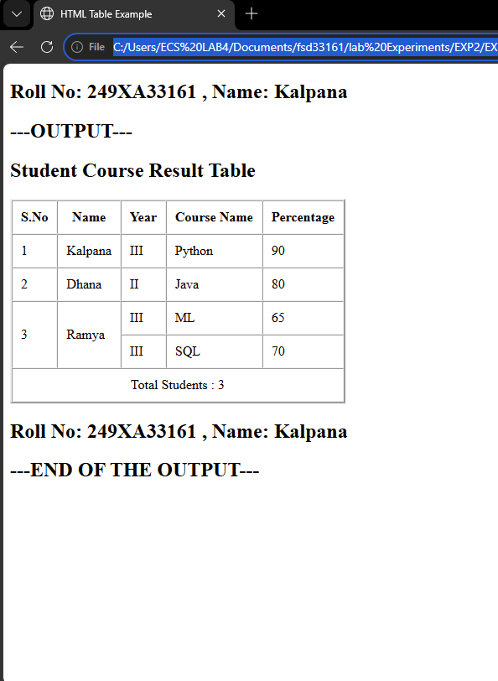



Experiment-2B: Date:
****
Aim: Write a HTML program, to explain the working of tables by preparing a timetable.
Source Code:
<!doctype html>
<html>
<head>
<title>Class Time Table</title>
</head>
<body>
<h2 align="center">Roll No: 249XA33161 , Name: Kalpana</h2>
<h2 align="center">---OUTPUT---</h2>
<br /><br />
<table border="2" cellpadding="10" cellspacing="5" align="center">
<caption>
<h2>III B.Tech CSE (AI & ML) Sec-C Time Table</h2>
</caption>

<tr bgcolor="lightgray">
<th>Day</th>
<th>9:00-10:00</th>
<th>10:00-11:00</th>
<th>11:00-11:20</th>
<th>11:20-12:20</th>
<th>12:20-1:20</th>
<th>1:20-2:00</th>
<th>2:00-3:00</th>
<th>3:00-4:00</th>
<th>4:00-5:00</th>
</tr>
<tr>
<td><b>Monday</b></td>
<td>NLP</td>
<td>OSSP</td>
<td rowspan="6" align="center"><b>BREAK</b></td>
<td>TPR</td>
<td>DVT</td>
<td rowspan="6" align="center"><b>LUNCH</b></td>
<td colspan="3" align="center">AI & System Programming Lab</td>
</tr>
<tr>
<td><b>Tuesday</b></td>
<td>OS</td>
<td>IQTA</td>
<td>NLP</td>
<td>DVT</td>
<td colspan="3" align="center">Full Stack Web Development-1 Lab</td>
</tr>
<tr>
<td><b>Wednesday</b></td>
<td>AI</td>
<td>IQTA</td>
<td>OS</td>
<td>TPR</td>
<td>DVT</td>
<td>IQTA</td>
<td>Mentoring</td>
</tr>
<tr>
<td><b>Thursday</b></td>
<td>NLP</td>
<td>CN</td>
<td>DVT</td>
<td>OSSP</td>
<td colspan="3" align="center">ITCA</td>
</tr>
<tr>
<td><b>Friday</b></td>
<td>DVT</td>
<td>NLP</td>
<td>OSSP</td>
<td>AI</td>
<td colspan="3" align="center">ITCA</td>
</tr>
<tr>
<td><b>Saturday</b></td>
<td>DVT</td>
<td>TPW</td>
<td colspan="2" align="center">ITCA</td>
<td>IQTA</td>
<td colspan="2" align="center">Practice Session</td>
</tr>
</table>
<br />
<br />
<h2 align="center">Roll No: 249XA33161 , Name: Kalpana</h2>
<h2 align="center">---END OF THE OUTPUT---</h2>
</body>
</html>

Snapshot of the Output Webpage:

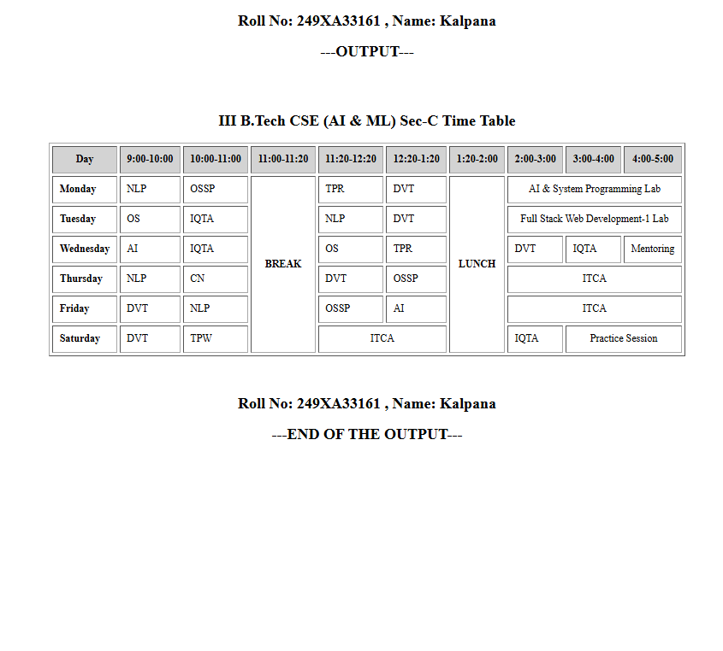

Experiment-2C: Date:
****
Aim: Write a HTML program to explain the workingof forms by designing Registration form.
Source Code:
<!doctype html>
<html lang="en">
<head>
<meta charset="UTF-8" />
<meta name="viewport" content="width=device-width, initial-scale=1.0" />
<title>Document</title>
</head>
<body>
<h2 align="center">Roll No: 249xa33161 , Name: Y.Kalpana</h2>
<h2 align="center">---OUTPUT---</h2>
<h2 align="center">Student Registration Form</h2>

<form>
<table border="1" cellpadding="10" align="center">
<tr>
<td>First Name</td>
<td><input type="text" name="name" /></td>
</tr>
<tr>
<td>Last Name</td>
<td><input type="text" name="name" /></td>
</tr>
<tr>
<td>Password</td>
<td><input type="password" name="password" /></td>
</tr>

<tr>
<td>Age</td>
<td><input type="number" name="age" /></td>
</tr>
<tr>
<td>Phone number</td>
<td><input type="phone number" name="phone number" /></td>
</tr>
<tr>
<td>Date of Birth</td>
<td><input type="date" name="dob" /></td>
</tr>

<tr>
<td>Gender</td>
<td>
<input type="radio" name="gender" /> Male
<input type="radio" name="gender" /> Female
<input type="radio" name="gender" /> Other
</td>
</tr>

<tr>
<td>Hobbies</td>
<td>
<input type="checkbox" /> Reading <input type="checkbox" /> Sports
<input type="checkbox" /> Music <input type="checkbox" /> Coding
</td>
</tr>

<tr>
<td>Branch</td>
<td>
<select>
<option>CSE</option>
<option>CSE (AI & ML)</option>
<option>ECE</option>
<option>EEE</option>
<option>Mechanical</option>
<option>Civil</option>
</select>
</td>
</tr>

<tr>
<td>Address</td>
<td>
<textarea rows="4" cols="30"></textarea>
</td>
</tr>

<tr>
<td colspan="2" align="center">
<input type="submit" value="Submit" />
<input type="reset" value="Reset" />
</td>
</tr>
</table>
</form>
<h2 align="center">Roll No: 249XA33161 , Name: Kalpana</h2>
<h2 align="center">---END OF THE OUTPUT---</h2>
</body>
</html>

Snapshot of the Output Webpage:
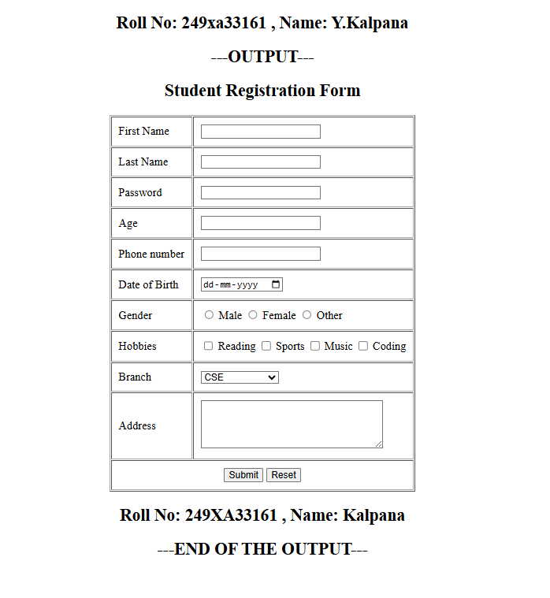

Experiment-2D: Date:
****
Aim: Write a HTML program to explain the working of frames, such that page is to be divided into 3 parts on either direction.
Source Code:
<!doctype html>
<html lang="en">
<head>
<meta charset="UTF-8" />
<meta name="viewport" content="width=device-width, initial-scale=1.0" />
<title>Document</title>
</head>
<frameset cols="30%,40%,30%">
<frame src="image.html" noresize></frame>
<frame src="paragraph.html" noresize></frame>
<frame src="links.html" noresize></frame>
<noframes>
<body>
<h2>Roll No: 249XA33161 , Name: Kalpana</h2>
<h2>---OUTPUT---</h2>
Your browser does not support frames.
<h2>Roll No: 249XA33161 , Name: Kalpana</h2>
<h2>---END OF THE OUTPUT---</h2>
</body>
</noframes>
</frameset>
</html>
Snapshot of the Output Webpage:
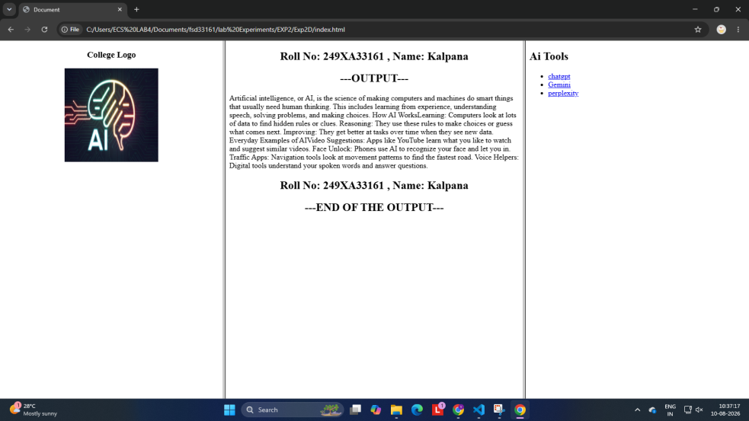

Experiment-2D: Date:
****
Aim: Write a HTML program to explain the working of frames, such that page is to be divided into 3 parts on either direction.
Source Code:
<!doctype html>
<html lang="en">
<head>
<meta charset="UTF-8" />
<meta name="viewport" content="width=device-width, initial-scale=1.0" />
<title>Document</title>
</head>
<frameset cols="30%,40%,30%">
<frame src="image.html" noresize></frame>
<frame src="paragraph.html" noresize></frame>
<frame src="links.html" noresize></frame>
<noframes>
<body>
<h2>Roll No: 249XA33161 , Name: Kalpana</h2>
<h2>---OUTPUT---</h2>
Your browser does not support frames.
<h2>Roll No: 249XA33161 , Name: Kalpana</h2>
<h2>---END OF THE OUTPUT---</h2>
</body>
</noframes>
</frameset>
</html>
Snapshot of the Output Webpage:

Experiment-3A: Date:
****
Aim: Write a HTML program, that makes use of <article>, <aside>, <figure>, <figcaption>,<footer>,<header>, <main>,<nav>,< section>,<div>, <span> tags..
Source Code:
<!doctype html>
<html>
<head>
<title>Frontend Development</title>
</head>
<body>
<h2>Roll No: 249XA33161, Name: Y KALPANA</h2>
<h2>----Output--</h2>
<br />
<header>
<h1>Full Stack Web Development Lab</h1>
<p>These are the parts of Full Stack</p>
</header>

<nav>
<a href="#">HTML</a> | <a href="#">CSS</a> | <a href="#">JavaScript</a>
</nav>

<section>
<article>
<h2>HTML,CSS,JS</h2>
<p></p>
</article>

<aside>
<h3>Did You Know?</h3>
<p>
Frontend development is the client-side part of a website or app that
users directly see and interact with.
</p>
</aside>
</section>

<figure>
<img
src="Front-End-Development.jpg"
width="250"
height="180"
alt="logos"
/>
<figcaption>Figure 1: Frontend</figcaption>
</figure>
<details>
<summary>Click to Know More</summary>
<p>
HTML provides the skeleton and structural content of the page. It is
a programming language; it is a markup language that uses "tags" to
the browser what the content CSS controls the visual presentation and
layout of the HTML elements. It transforms a plain text document into
beautiful, designed webpage. JavaScript is a full programming language
that brings the webpage to life by adding interactivity and logic.
</p>
</details>

<footer>
<p>G. Pulla Reddy Engineering College</p>
</footer>
<br />
<h2>----End of the Output--</h2>
<h2>Roll No: 249XA33161, Name: Y KALPANA</h2>
</body>
</html>

Snapshot of the Output Webpage:
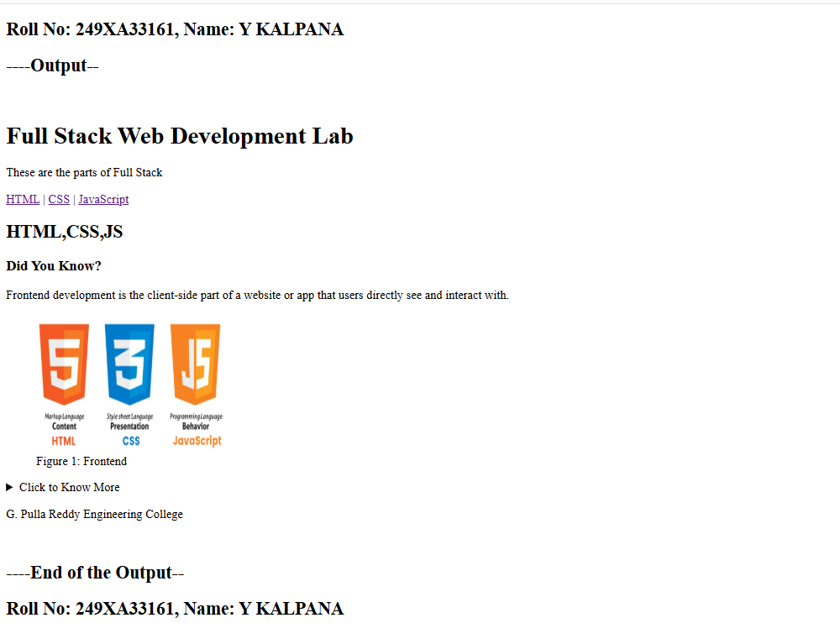
Experiment-3B: Date:
****
Aim: Write a HTML program, to embed audio and video into HTML web page.
Source Code:

Experiment-3C: Date:
****
Aim: Write a program to apply different types (or levels of styles or style specification formats) - inline, internal, external styles to HTML elements (identify selector, property and value).
Source Code: (HTML)
<!doctype html>
<html>
<head>
<title>Types of CSS</title>

<link rel="stylesheet" href="style.css" />

<style>
h2 {
color: black;
text-align: center;
}

p {
color: purple;
font-size: 20px;
text-align: center;
}
</style>
</head>

<body>
<h2>Roll No: 249XA33161, Name: Y KALPANA</h2>
<h2>----Output--</h2>
<br /><br />
<h2>Internal CSS Example</h2>

<p>This paragraph uses Internal CSS.</p>

<h3 style="color: rgb(218, 39, 39); text-align: center">
This heading uses Inline CSS.
</h3>

<h1>This heading uses External CSS.</h1>
<br /><br />
<h2>----End of the Output--</h2>
<h2>Roll No: 249XA33161, Name: Y KALPANA</h2>
</body>
</html>

CSS :
h1 {
color: purple;
text-align: center;
background-color: rgb(135, 212, 212);
border: 2px solid black;
padding: 10px;
}

Snapshot of the Output Webpage:

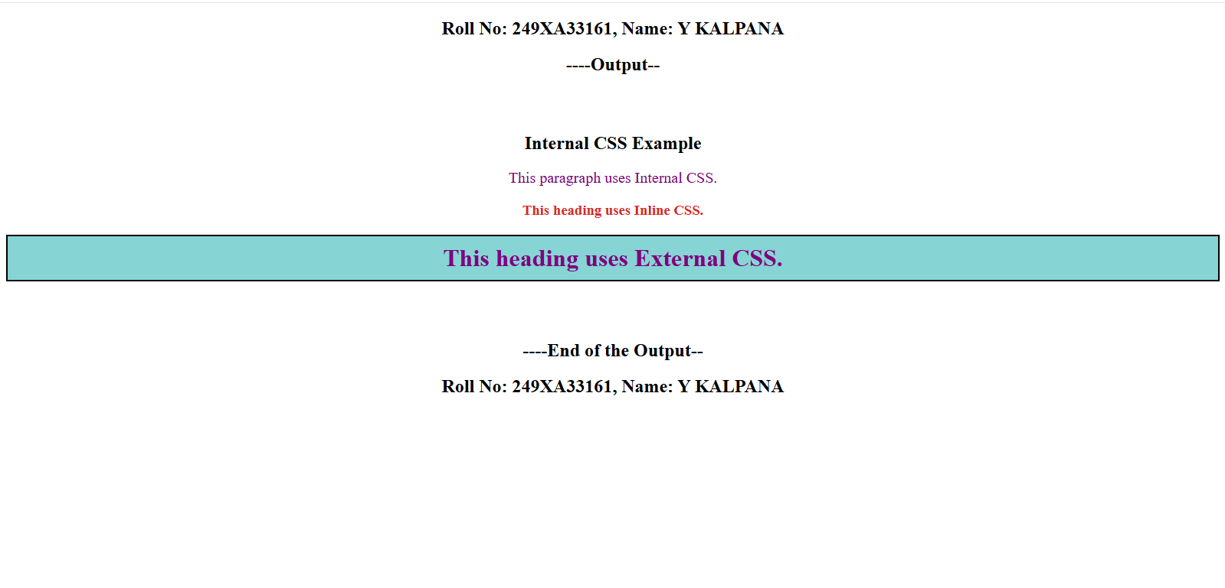

Experiment-2D: Date:
****
Aim: Write a HTML program to explain the working of frames, such that page is to be divided into 3 parts on either direction.
Source Code:
<!doctype html>
<html lang="en">
<head>
<meta charset="UTF-8" />
<meta name="viewport" content="width=device-width, initial-scale=1.0" />
<title>Document</title>
</head>
<frameset cols="30%,40%,30%">
<frame src="image.html" noresize></frame>
<frame src="paragraph.html" noresize></frame>
<frame src="links.html" noresize></frame>
<noframes>
<body>
<h2>Roll No: 249XA33161 , Name: Kalpana</h2>
<h2>---OUTPUT---</h2>
Your browser does not support frames.
<h2>Roll No: 249XA33161 , Name: Kalpana</h2>
<h2>---END OF THE OUTPUT---</h2>
</body>
</noframes>
</frameset>
</html>
Snapshot of the Output Webpage:

